PF Project report

1St semester 2021

Team members: Ahmed Ali (21k-3212) Taha hassan (21k-4680) Shayan Haider (21k-3211)

FAST

Contents

Introduction 1

Background 2

Solution Design 3

Implementation and testing 4

Project Breakdown Structure 9

Conclusion 10

Results 10

# Introduction

## Aim

Our aim was to create the best user-friendly version of Tic tac toe, that will increase the fun in playing that game. As it is widely known game, it was a good opportunity for us to introduce some new amendments in the game.

December 17, 2021

# Background

Stdio.h was used for performing simple programming tasks such as scanf () and printf ().

Conio.h library was used functions like getch () and kbhit () functions.

Stdlib.h was used for exit (), system (), srand () and rand () functions.

ctype.h was used for texting and mapping characters.

# Solution Design

The program displays a start-up panel in the beginning, showing the name of the game. The name is followed by the starting menu which contains four options. The options can accessed with down arrow keys. The four options are as follows: “Play”, “Credits”, “Instructions”, “Exit”. The credits option upon being selected will display the credit points. The Instructions manual will direct the users to the instructions of the game. The exit option will allow the users to quit the game. The play option will present the user with choices to play the game, Sigle player or multiplayer. If user selects the single player option he will then play with computer. Whereas the multiplayer option would ask player 1 to enter a block number against which he wishes to enter his symbol. Then the player two would be asked to enter a block number against which he wishes to enter his symbol. The process will repeat until the users run out of option and a result is decided. The result has three possibilities, victory for either of the user or a tie. After the outcome the user is presented with two choices to either continue or exit the game.

# Implementation and testing

Firstly, the name of the game is displayed, which was made using ASCII ARTS. As shown in the program the function char head() is used to display the heading.

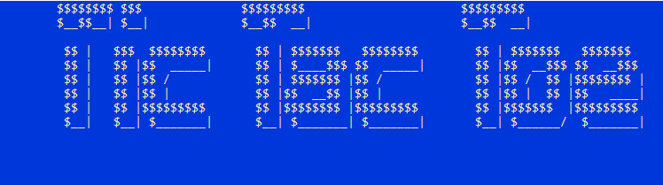

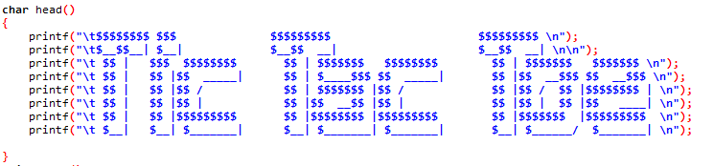

When play option is chosen a board appears Infront of the users. This is done using the board() function in the program.

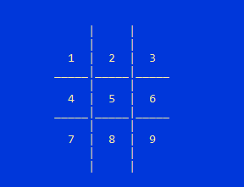

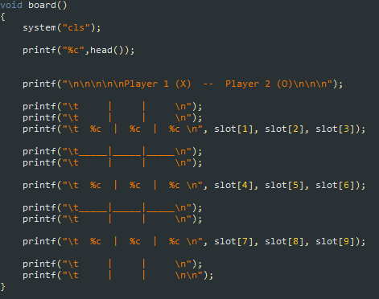

After pressing the play button, If user selects the 1player option he will then play against the computer. The player would be asked to enter his block number. Then the computer would enter its block random through the help of flag, which will mark that particular block number ass occupied.

If multiplayer(2player) option is selected. Then the player 1 has to choose the block against which he wishes to enter his symbol. The selected block is then occupied with the player one’s symbol, and then the player 2 is given the opportunity to select the block from the remaining ones. If the user enters an out-of-range block number, the program displays a warning of “Invalid move”. Below is the screenshot of this operation.

The selection of blocks by player 1 followed by player 2 repeats until the choices run out.

Then the evaluation of the result takes place using the function checkwin() function. The return value of this function is stored in a variable **i**. In the function checkwin() the choices of each player are matched and if an acceptable pattern is there, the function returns an integer value of 1. Otherwise, the function returns 0. This determines the result of the game which is then printed using printf in the if conditions.

NOTE: If 1player option is selected the in-case of the victory for the computer, the program will display “computer win”.

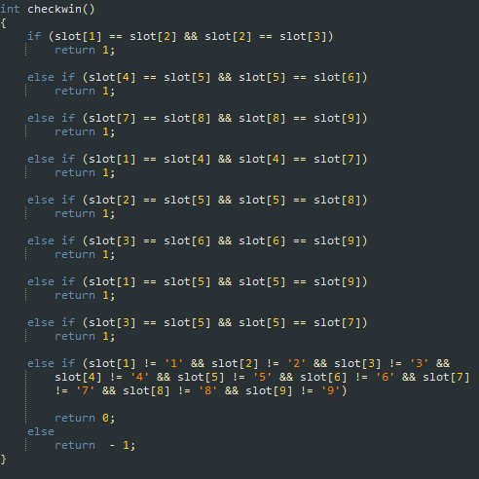

After the result of first game, the program presents two choices to user to either continue or exit by entering ‘Y’ for continuing or ‘N’ for exiting. The response is stored in a variable named response. The response variable is sent to switch case statement to decide the future action.

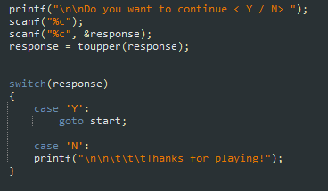

# Project Breakdown Structure

We evenly distributed the workload, to increase the efficiency of our product. First stage involved a thorough research and gathering of the ideas regarding the project. Our first stage was completed on 5th of November 2021. Second stage involved the implementation of those ideas and research in the form a program. This stage was completed till 18th of November 2021. After the second stage we immediately moved on to the third stage. This stage involved getting rid of errors, bugs and glitches which were shown in our first draft of the program. This stage was completed till 30th November 2021. The fourth and final stage consisted of the further enhancement of our project like improving the quality of functions, reducing line of codes and minimizing the response rate of our program to provide the best user experience. Our project was completely ready on 12th December 2021.

# Results

The results and response of the program are fully satisfactory. Our efforts and hard work is reflected from the project. Although, we were unable to implement some extraordinary ideas due to the advance complexity and the challenges that they opposed on us. Despite those hurdles, we utilized our resources and skills to come up with the project.

**Conclusions**

We are delighted to complete our project on time, and hope that our project will perform extremely well and would be appreciated.